Neo4j Cypher
25th May 2025 R00225669 Rebecca Lordan
Neo4J CRUD Movie Database
Task 1
Movie Graph Nodes
Movie Node, label is Movie and properties are title, released (year), tagline
Person Node, label is Person and properties are name, born (year)
Movie Graph Relationships
ACTED_IN, connects a Person to a Movie
DIRECTED, connects a Person to a Movie
PRODUCED, connects a Person to a Movie
WROTE, connects a Person to a Movie
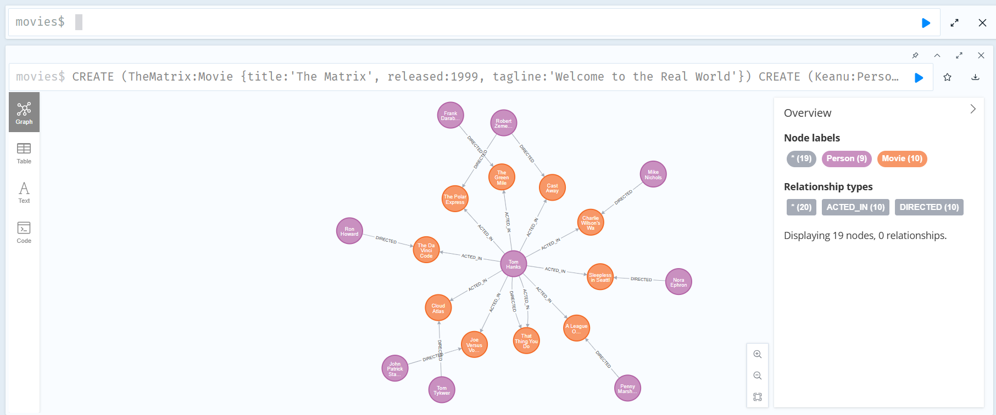
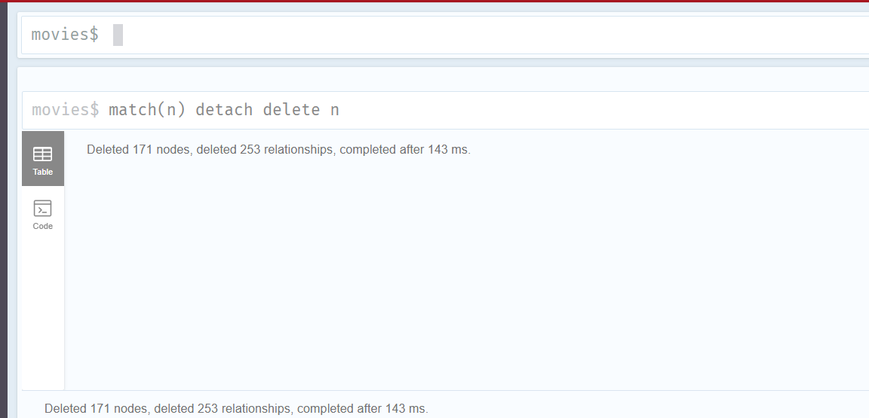

1. Add movie, actor (three main characters), director as vertices and ACTED_IN/DIRECTED edges for movie “The Bridges of Madison County” The Bridges of Madison County (1995) - IMDb [PS. Do not insert vertices that already exist in the database, and make sure the database does not contain any dummy nodes]
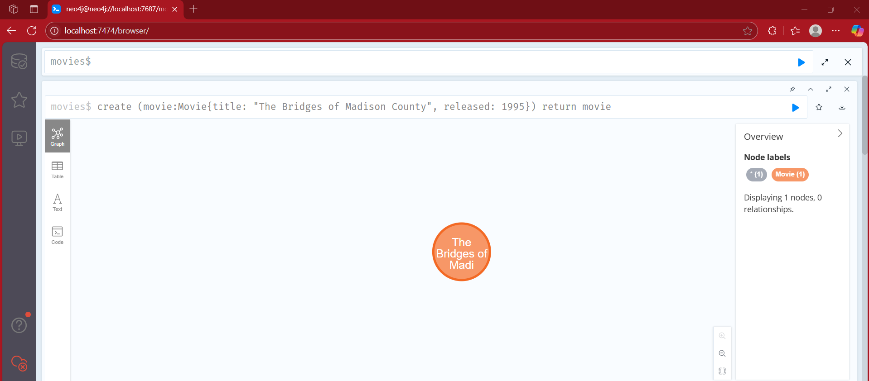
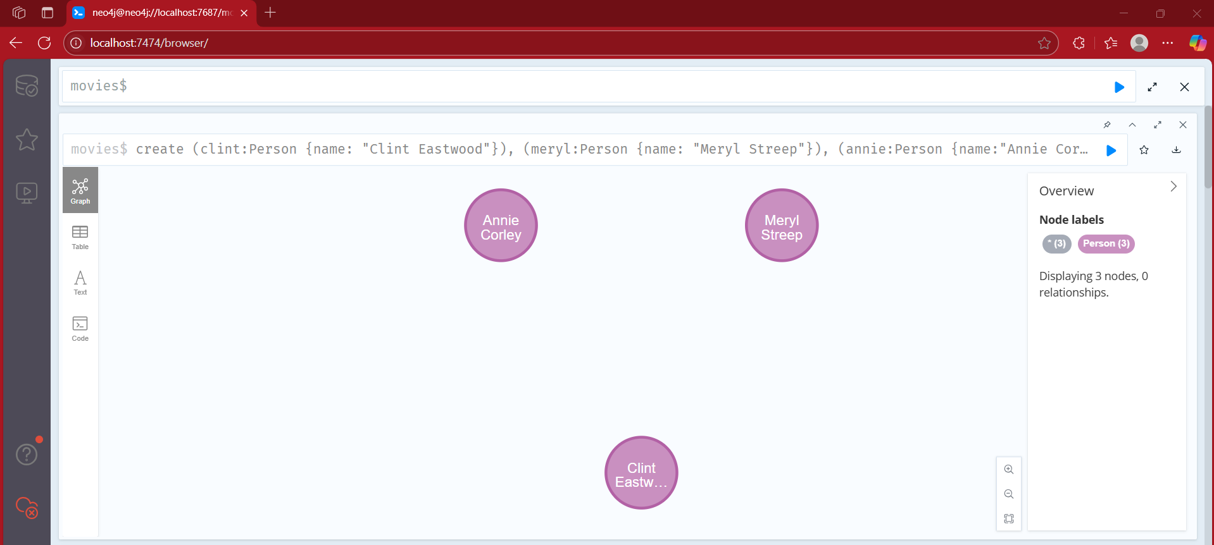
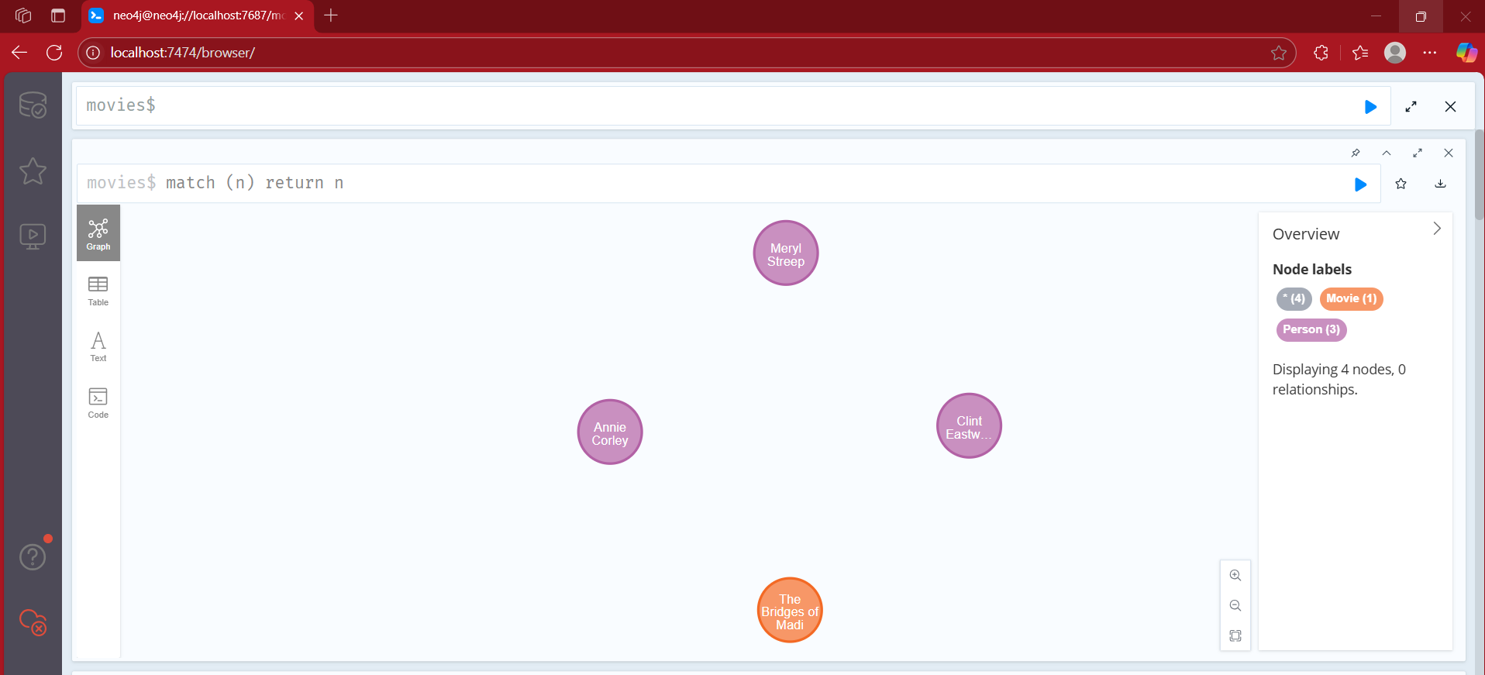
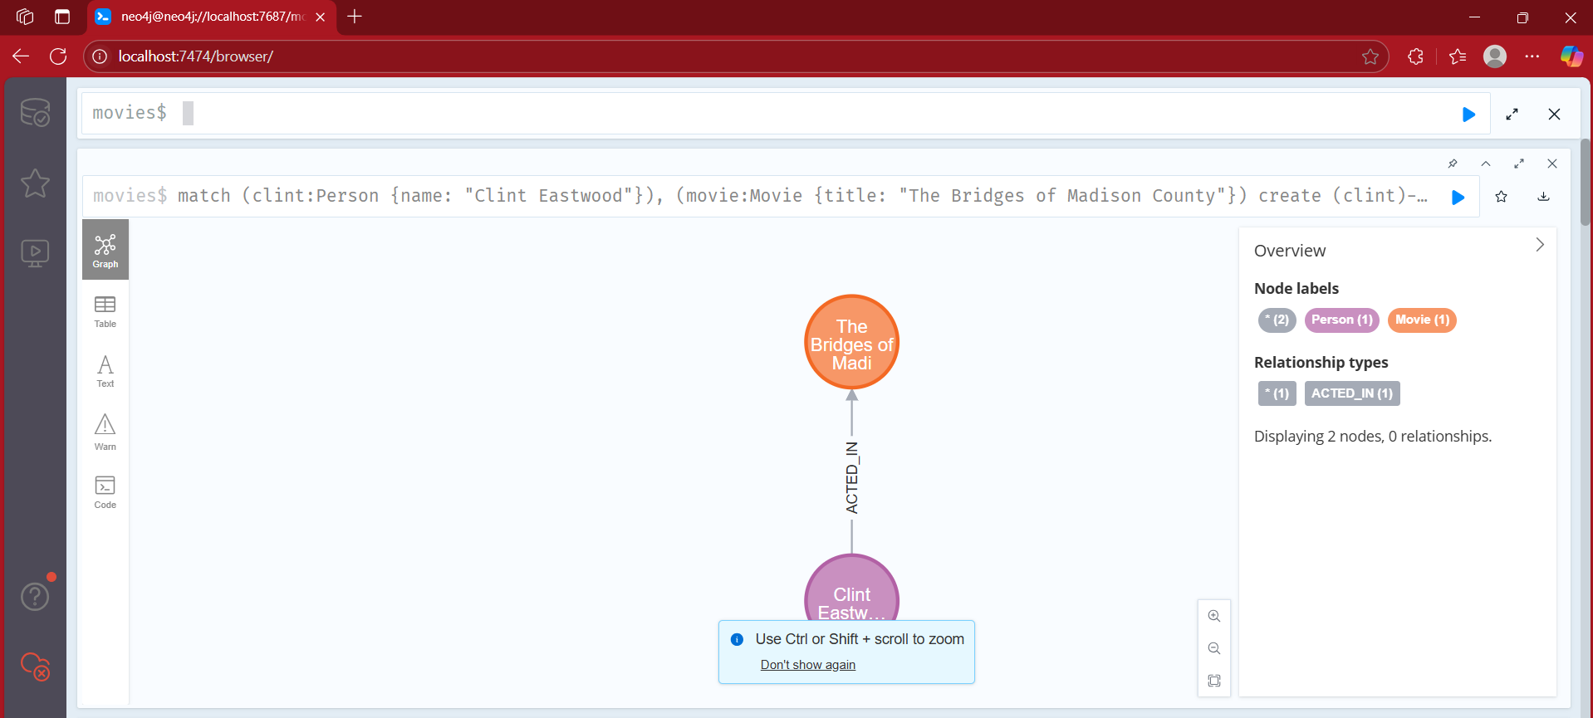
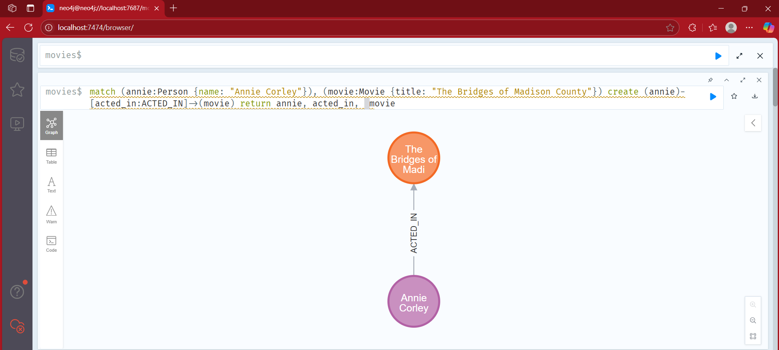
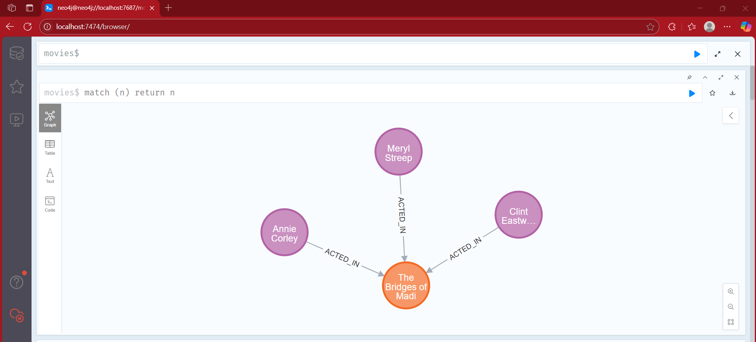
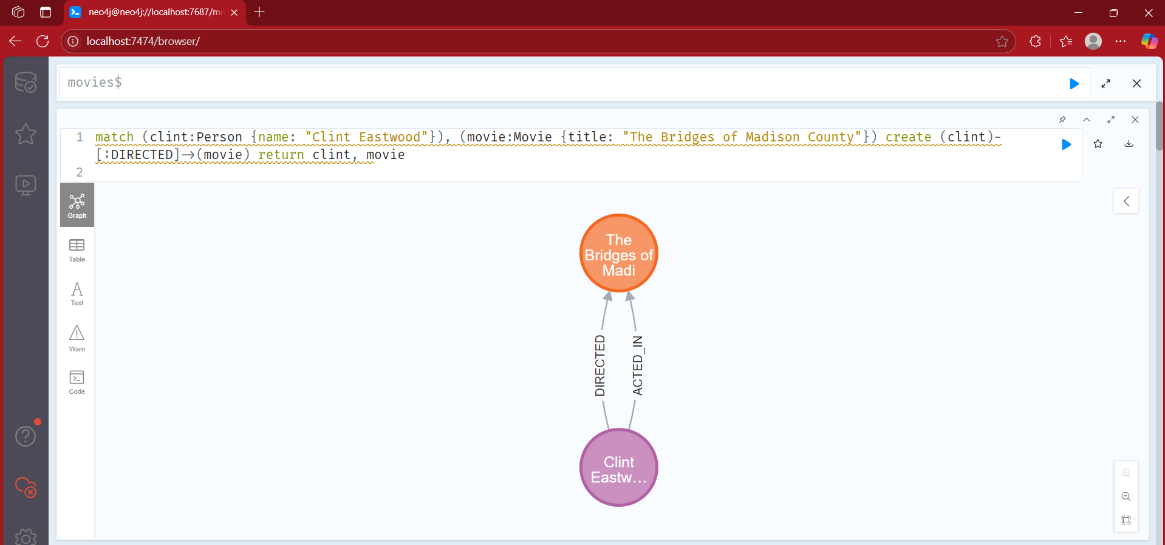
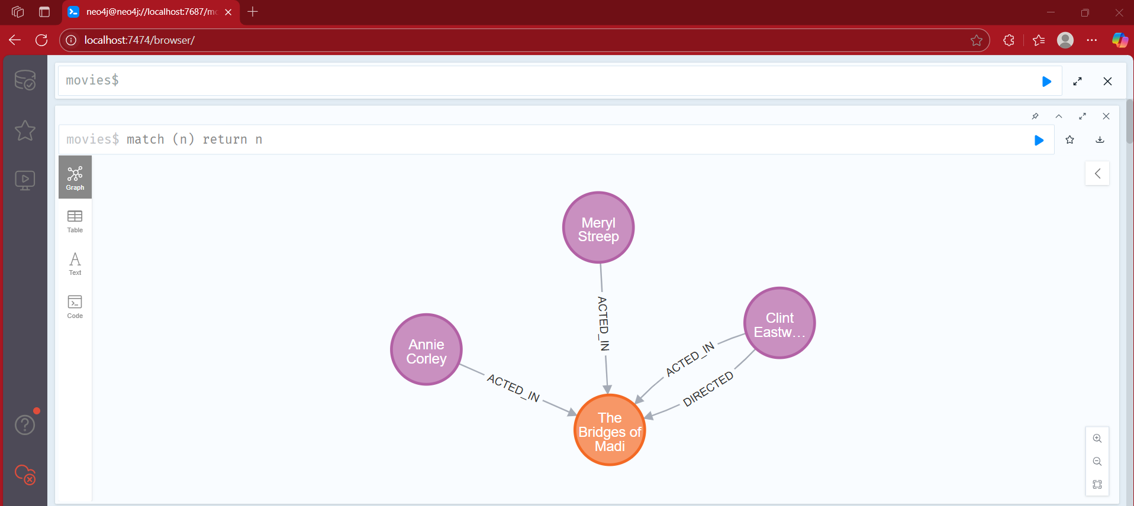
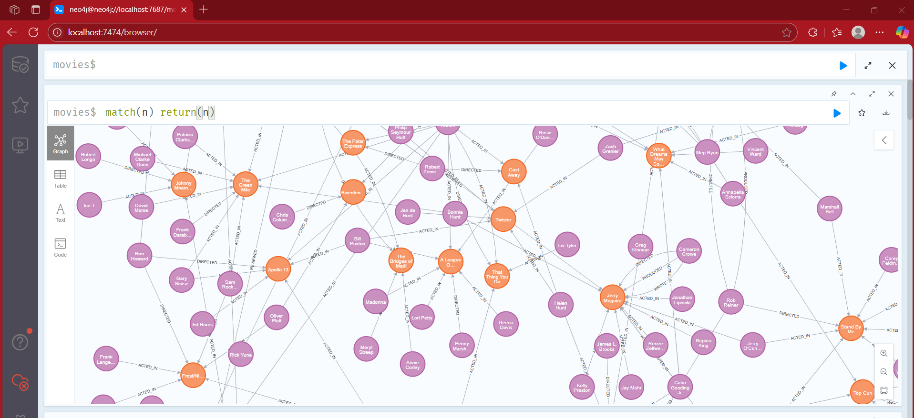

2. Find all actors that directed a movie they also acted in and return actor and movies
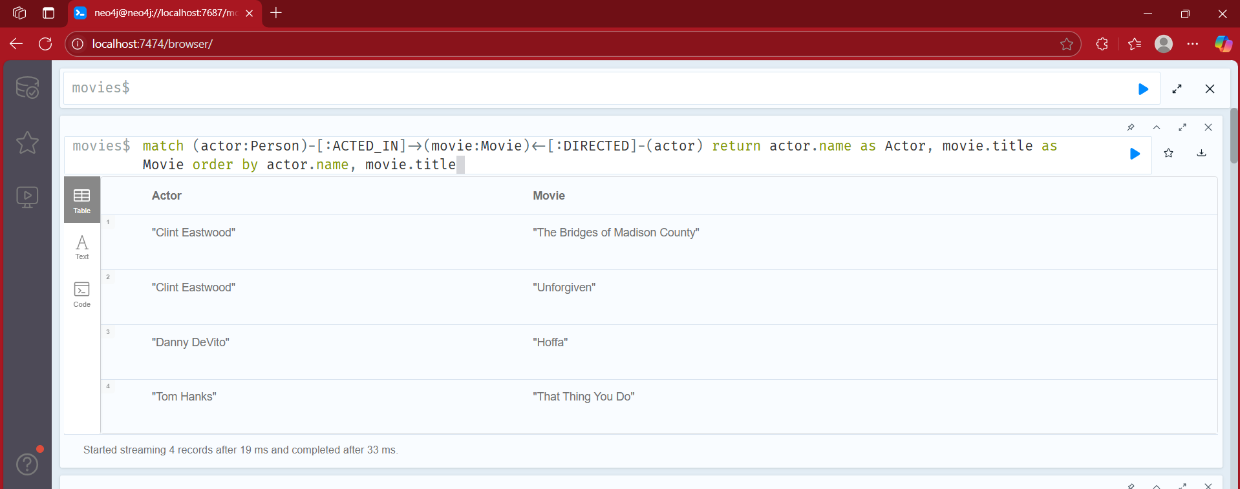

3. Find all actor pairs that acted in multiple movies together
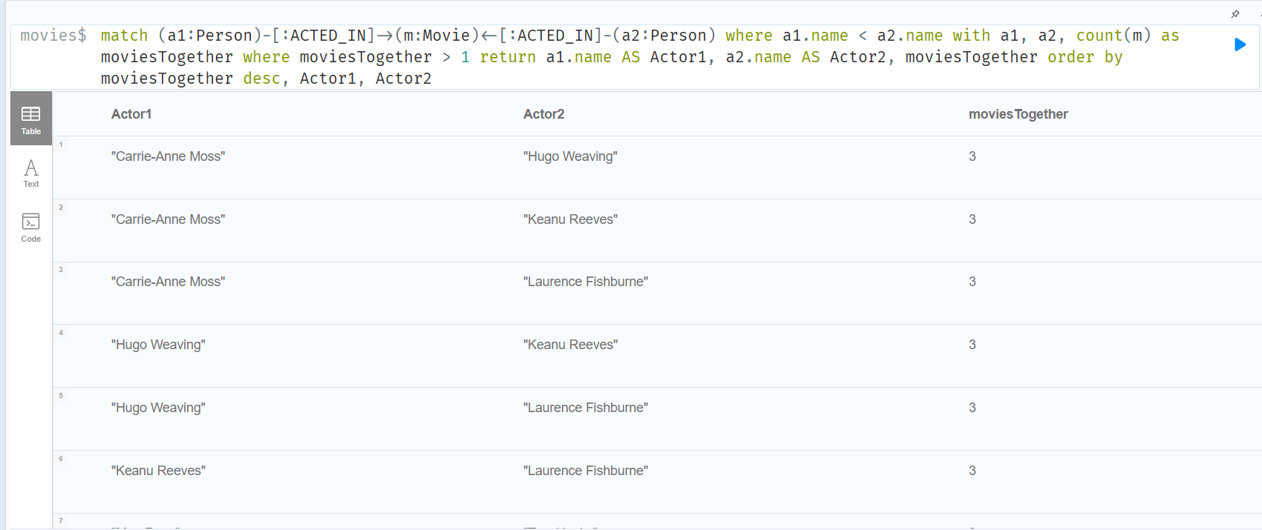

4. Find all movies that Keanu Reeves has acted in and the co-actors that acted in the same movie, returning the movie title and the list of co-actors that Keanu Reeves worked with.
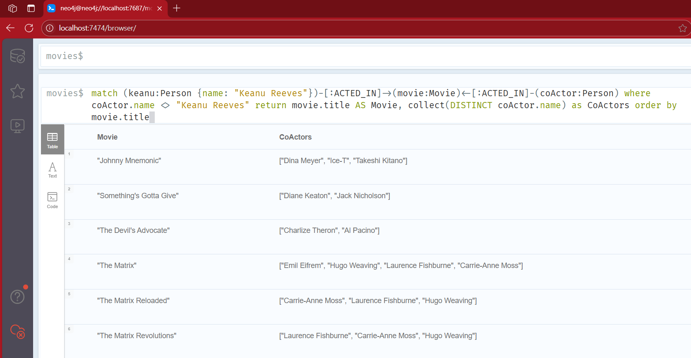

5. Delete the movies that have the lowest rating.
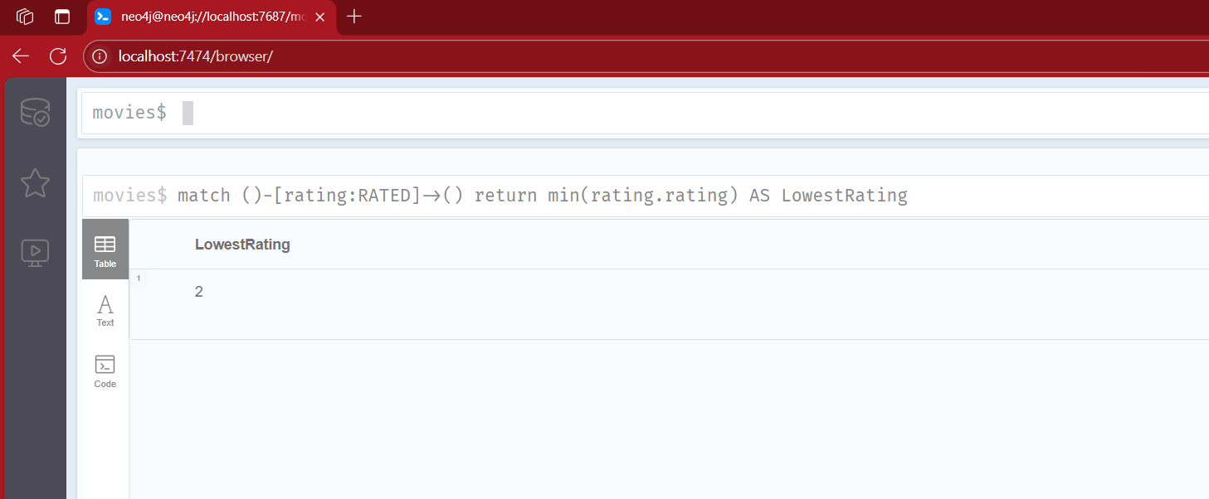
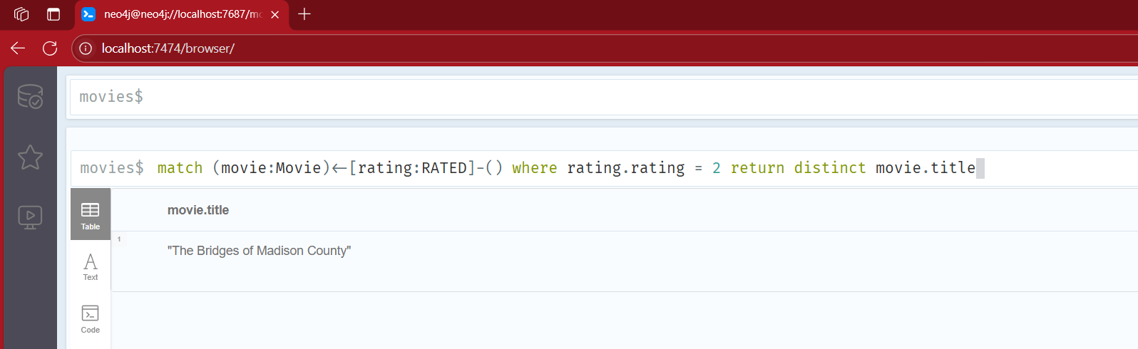
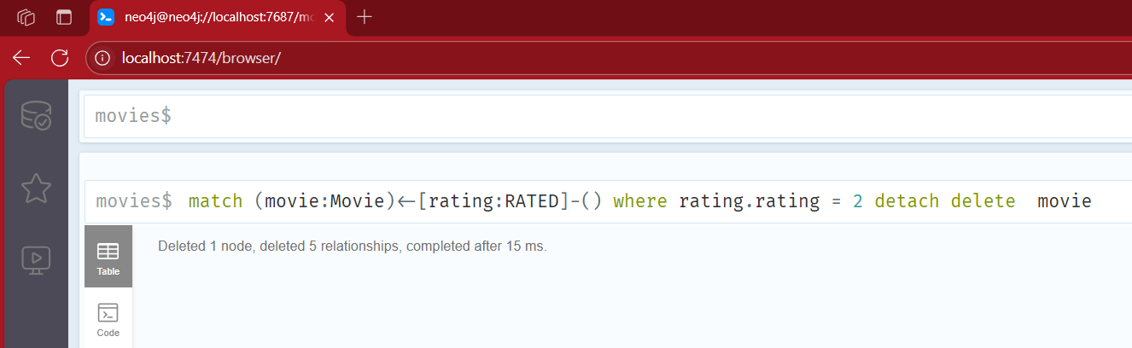

Task 2
1. List all female young female students, age below 20, prefer to visual learning style on their courses in high school and they are unlikely to drop out their courses.
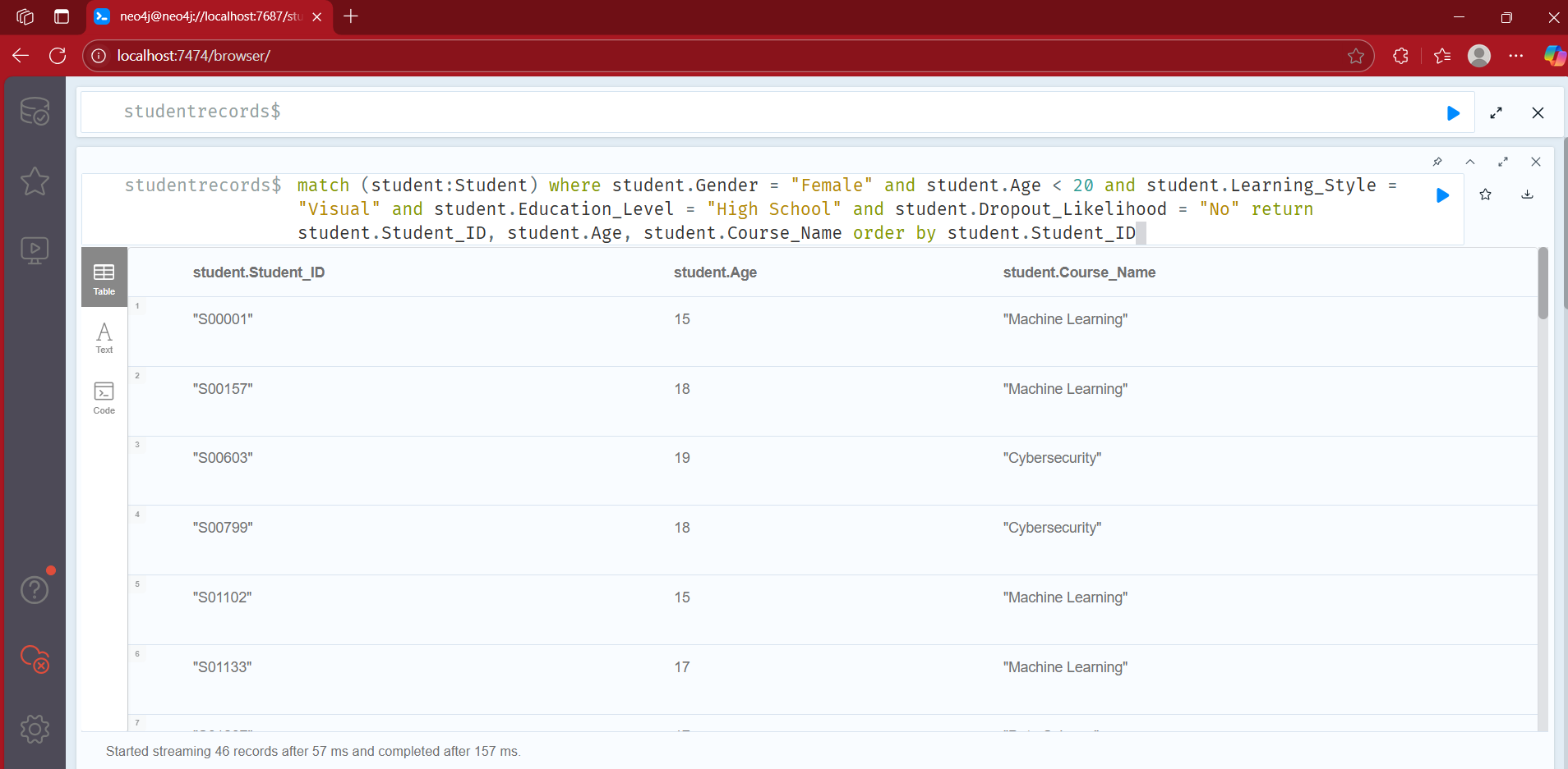

2. List all courses at various educational level that have been actively engaged by students and have highest assignments completion rate.
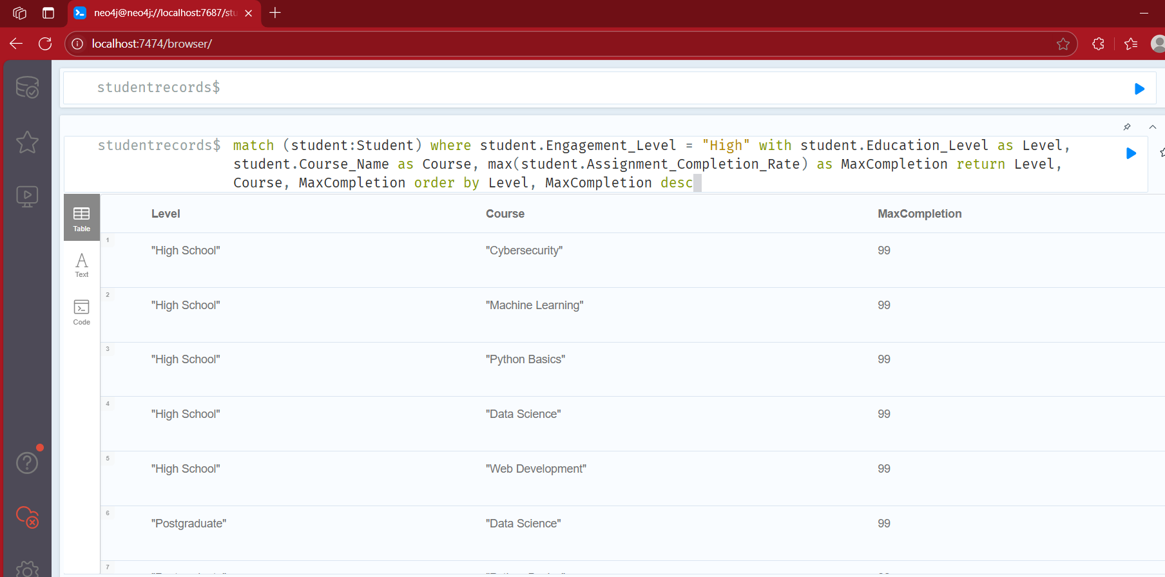

3. Which course has received the highest feedback rating score?
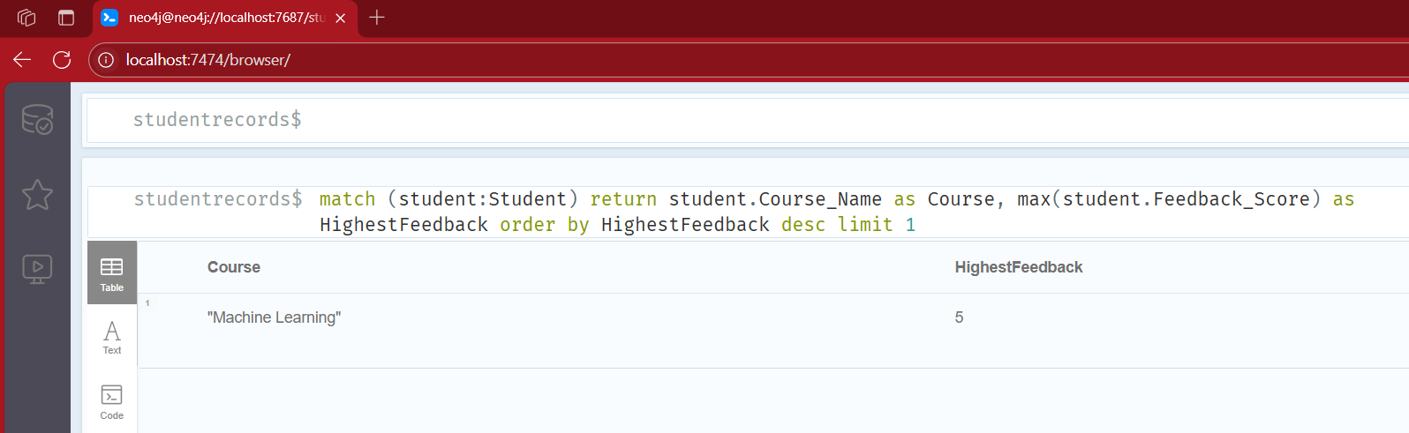

4. How many male students have failed the cybersecurity final exam (below 40) due to the low engagement?
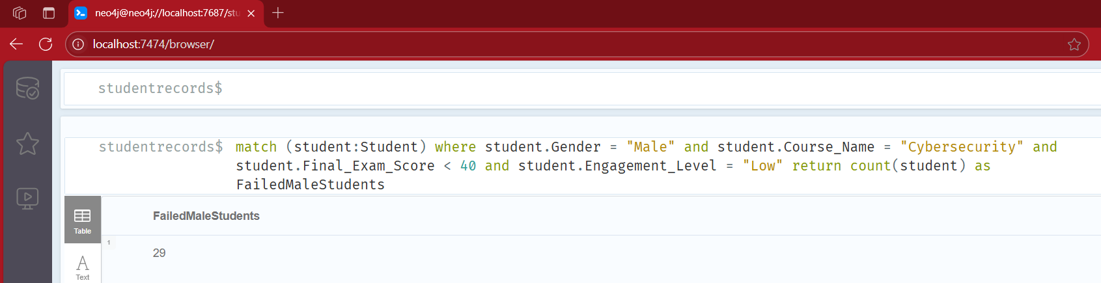

5. How many students will likely to drop out their courses due to low engagement and list out their learning style and their educational level.
